Introduction
To enable users in your organization to log in with their Microsoft Entra ID identities, you must first set up a SpecterX App in your Entra ID. This will allow SpecterX to turn to Azure for authentication.

To renew credentials for an existing Entra ID <> SpecterX federation, go directly to the section for creating a secret, and use the secure upload link provided by the SpecterX team to transfer the new secret value.

Option 1: Run the SpecterX Entra ID Configuration Tool (Recommended)
The SpecterX Entra ID Setup tool performs the full configuration for you. Nothing runs until you click Run on each step. If a pre-check fails, the tool prints a message instead of executing.

What you’ll need
- Microsoft Entra ID Global Administrator credentials.
- The SpecterX-provided Redirect URI (you’ll receive this from the SpecterX team).
- A secure upload link from SpecterX to deliver the resulting credentials (provided by the SpecterX team).

Instructions
- Check endpoint prerequisites
Click Run to validate network access and required endpoints.
- Connect to Entra ID
Click Run, then sign in with your Global Administrator account.
  - The tool establishes a session to perform the remaining steps.
- Create App Registration
Click Run to create a single-tenant app registration named:
SpecterX App Federated login
  - The tool captures the Application (client) ID and OpenID Connect metadata document URL required for the handoff.
- Set App Redirect URIs
Click Run to configure the Web redirect URIs.
  - Use the Redirect URI provided by the SpecterX team.
  - The tool will set the Web platform and apply the URIs accordingly.
- Enable implicit access tokens
Click Run to enable Access tokens (used for implicit flows) under Implicit and hybrid flows.
- Create App client secret
Click Run to create a new client secret (e.g., description SpecterX IdP, 24-month expiry).
  - The tool will display the secret value and capture it for the handoff.
- Print & save handoff JSON
Click Run to generate a local handoff JSON that includes everything SpecterX needs to complete the federation on our side:
  - Application (client) ID
Tenant ID
  - OpenID Connect metadata document URL
  - Redirect URIs applied
  - Newly created client secret value

Send credentials to SpecterX
Do not email secrets. Use the secure upload link provided by the SpecterX team to transfer the handoff JSON (and, if shown separately by the tool, the secret value). Once uploaded, SpecterX will complete the tenant-side federation and confirm readiness.

Option 2: Manual Configuration

Step 1: Set up App Registration
- Go to the Customer’s Azure Admin Portal - https://portal.azure.com/#home
- Browse using the top search for Microsoft Entra ID
- Choose ‘App Registrations’
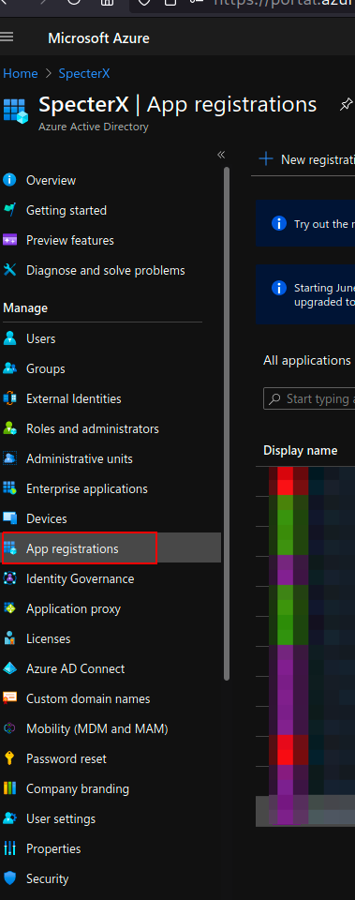
- Click “+ New registration” and fill in the following details:
  - Name: SpecterX App Federated login
  - Supported account types: Accounts in this organizational directory only (Single tenant)
  - Don’t enter “Redirect URI” at this stage
  - It should look like this
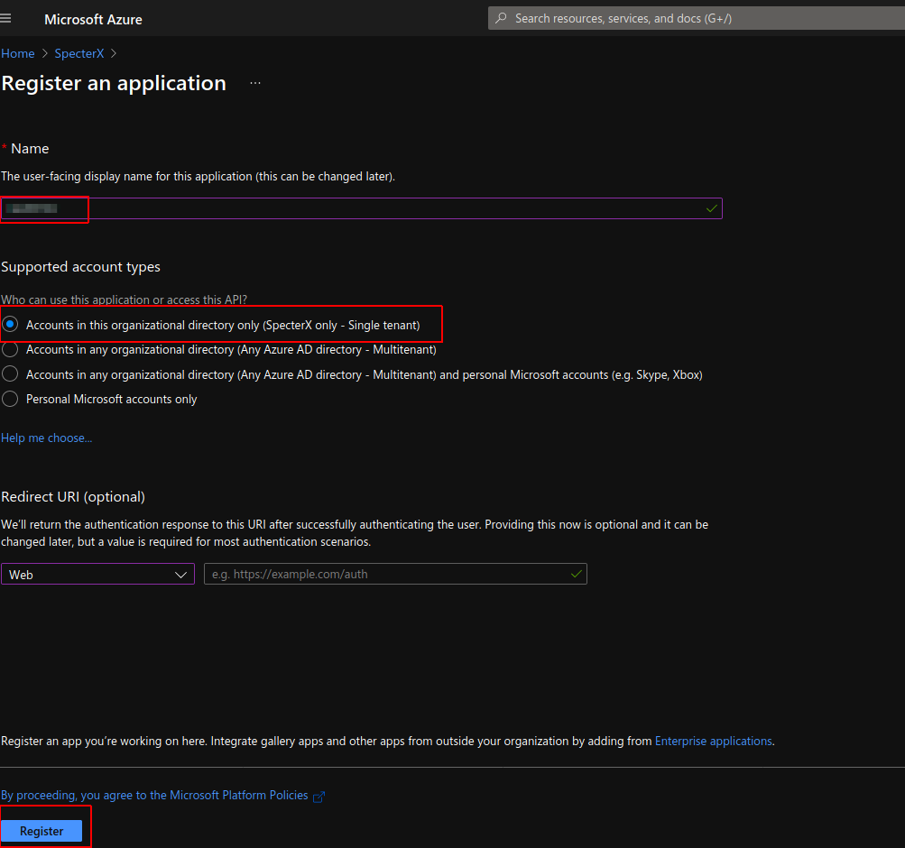
- Click “Register”
- Browse to the newly registered app
  - Copy and save Application (client) ID
- Click ‘Endpoints’.
  - Copy and save “OpenID Connect metadata document” URL
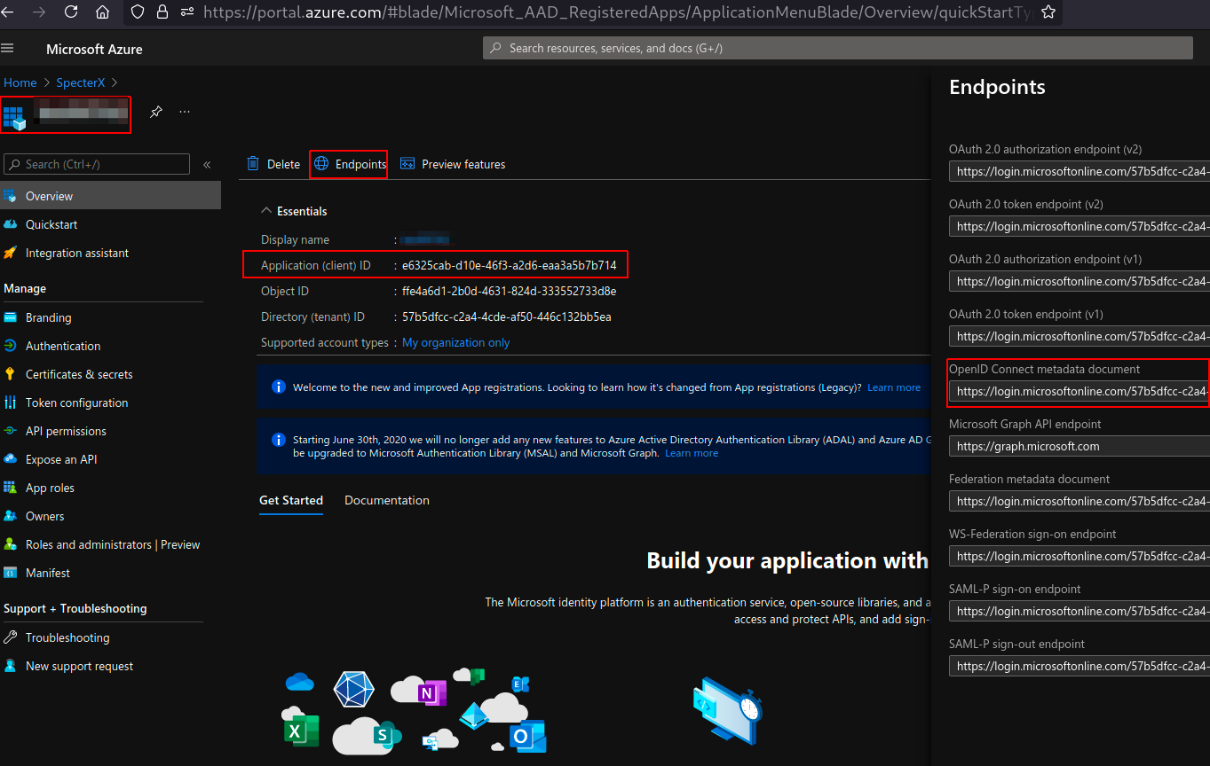

Creating a Secret
Creating a secret in Entra ID acts as a confidential key for your Entra ID’s secure communication with SpecterX.

- If you’re not already on the relevant app page in Azure, go to App Registrations in the Azure Admin Portal and find the app created for SpecterX authentication (should be under the name ‘SpecterX App Federated login’).
- Go to “Certificates and Secrets” on the left menu
- Under “Client Secrets” click “+ New client secret”
  - Set “SpecterX IdP” as the name
  - Set expiration to 24 months
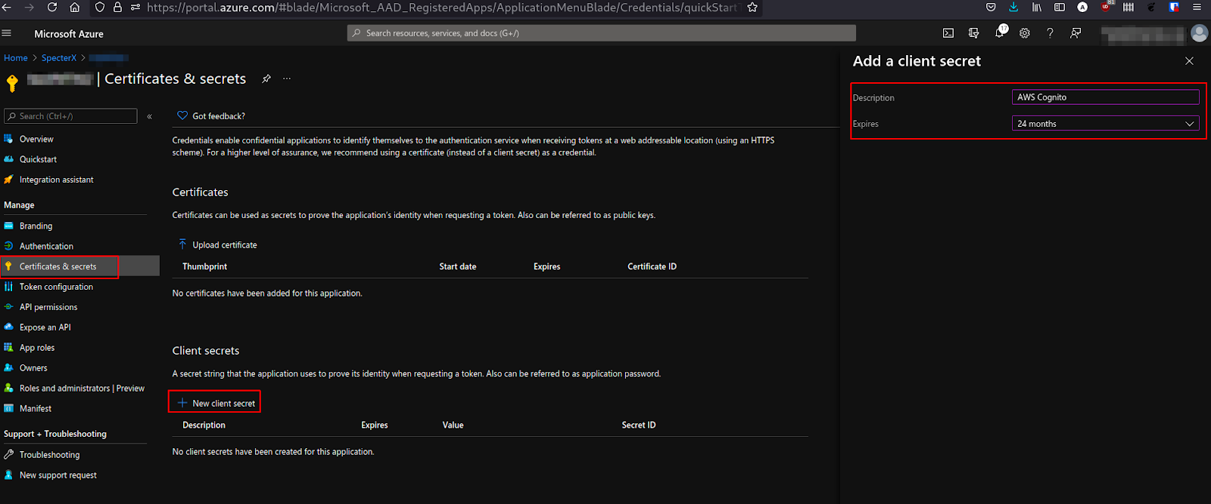
  - Click “Add” and you’ll see the secret “Value” in the “Client Secrets” table - copy it.
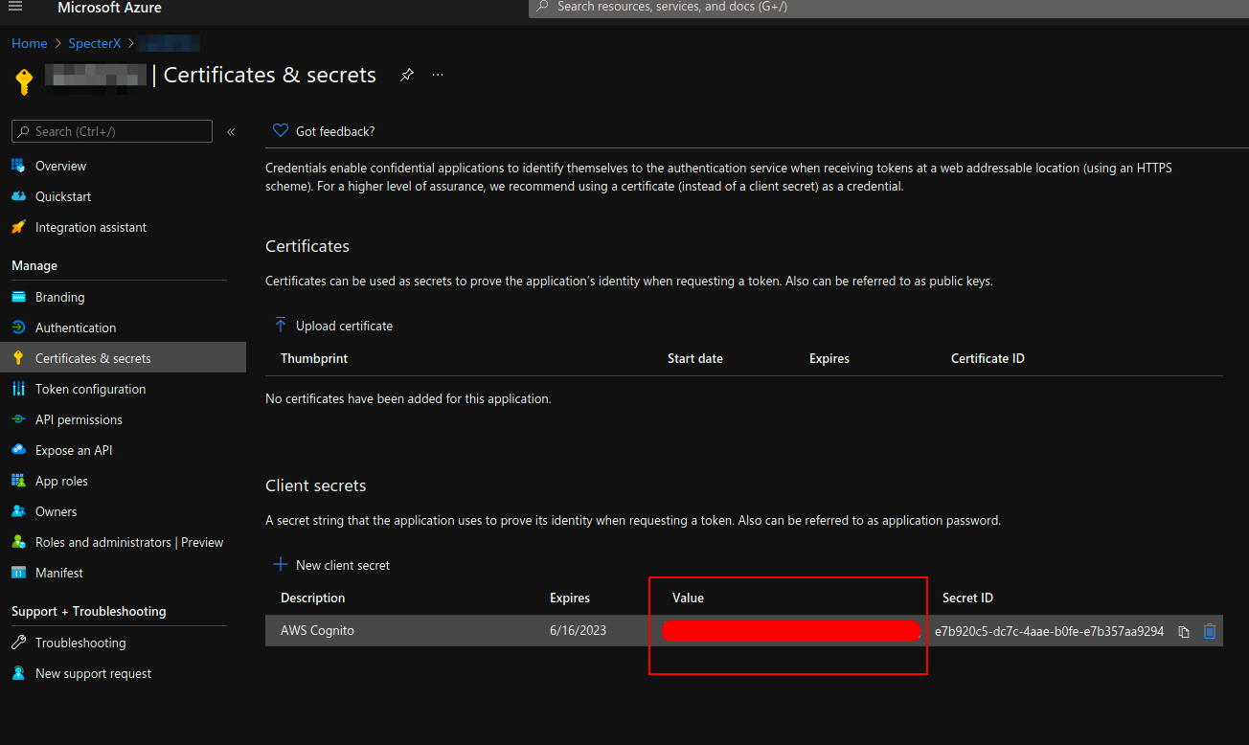

- Send the newly created secret value to a SpecterX support representative.

Step 2: Add Authentication Methods
- Return to the App Authentication menu to begin configuring the SpecterX app's authentication:

Setting up Web authentication
- Click on “+ Add platform” and select “Web” and click configure
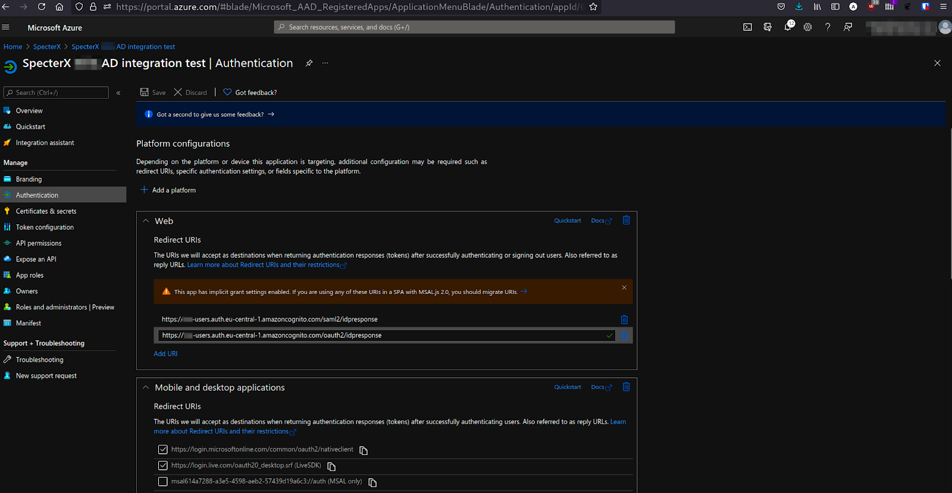Using the “Domain name” configured in AWS Cognito, make sure there are 2 redirect URIs:
- https://{customer}-users.auth.{tenant-region}.amazoncognito.com/saml2/idpresponse
- https://{customer}-users.auth.{tenant-region}.amazoncognito.com/oauth2/idpresponse

Setting up Authentication for Add-ins and other SpecterX components
- Click on “+ Add platform” again and select “Mobile and desktop applications”
- Select the following 2:
  - https://login.microsoftonline.com/common/oauth2/nativeclient
  - https://login.live.com/oauth20_desktop.srf
- On the same page, find under “Implicit and hybrid flows” a checkbox named Access tokens (used for implicit flows) and check it.
- Click Save.

Send credentials to SpecterX
Do not email secrets. Use the secure upload link provided by the SpecterX team to transfer the information you’ve collected while running the manual steps. Once uploaded, SpecterX will complete the tenant-side federation and confirm readiness.

Run the Entra ID Test Configuration Tool
After following the manual either by option #1 or #2, you should validate your setup using the SpecterX Entra Test Configuration Tool provided by the SpecterX team.
This PowerShell script verifies that your configuration works correctly by testing authentication and token issuance.

Instructions
- Download the Test-Entra-Config.ps1 file from the secure link provided by SpecterX.
- Open PowerShell as Administrator.
Run the following command, replacing the parameters with your actual values from the handoff JSON:
Test-Entra-Config.ps1 -TenantId <Tenant_ID> -ClientId <Client_ID> -ClientSecret <Secret Value>
- Wait for the script to complete. It will:
  - Validate the connection to Entra ID
  - Test token acquisition using your app registration

